Circuit Construction Kit SIM Homework
1) In this problem, you will use the Circuit Construction Kit (CCK) Simulation to learn more about how your home wiring works. You can access the CCK Simulation from http://phet.colorado.edu/simulations/sims.php?sim=Circuit_Construction_Kit. Below is a screenshot of the CCK where the battery is acting to simulate the power lines into your house. A pair of wires is shown connecting these power lines to an outlet in your home. Plugged into this outlet you have a light bulb.
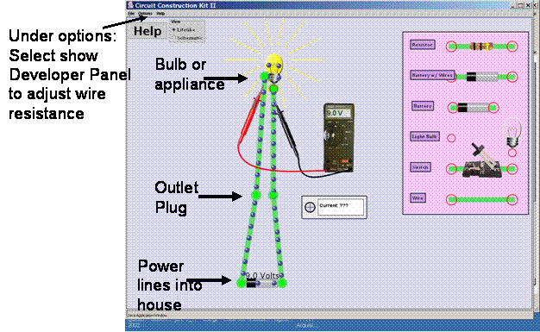
a) Construct this circuit within the CCK simulation. Your house has new thick wiring that has very little resistance. Right click on the bulb and select change value to adjust the resistance of the bulb.
i) (0.5 pts) With the resistance of the bulb at 37 ohms, how much power is going into the bulb?
ii) (1 pt) How does this bulb brightness compare to the brightness of the bulb when the resistance of the bulb is 1 ohm? Explain the physics reasoning behind why the bulb brightness changes.
iii) (0.5 pts) If you had a 100 Watt bulb plugged into one outlet and a 1500 Watt electric heater plugged into another outlet,
the resistance of the heater would be larger than the resistance of the bulb.
the resistance of the heater would be smaller than the resistance of the bulb.
the resistance of the heater could be either small than or larger than the resistance of the bulb because the resistance will depend on the current.
b) New heavy duty wires will have only a small resistance. If your house is an older home (i.e. built 100 years ago), the old thin wires will have larger resistance. This increase in resistance in the wiring has several effects. In the simulation, select the developer panel under the options menu and begin increasing the resistance of the wires. You can measure the voltage drop between any two points in the circuit by using the volt meter.
i) (2 pts) Set the bulb resistance to be about 2 ohms. As you increase the resistance in the wires, what changes do you see in (1) the current, (2) where the electrons loose their energy, and (3) the amount of power (energy per second) that is being used by this circuit? (Hint: use all of the visual cues and the tools you have like the volt meter to explore the changes). Be sure to explain the physics reasoning behind why these changes make sense given an increase in the resistance of the wires.
ii) (1 pt) Given your observations in the previous question, how would using old thin wires affect the brightness of the bulb and the temperature of the wires compared to using new, thick wires with very little resistance? Explain.

