States of Matter- Student Guide: Name: ________________
Start: 1.
Google: PhET states of matter
2. Click on the first link
3. Click on the button.
4.  Explore the simulation. Be sure to click on everything.
Write two things you think the simulation is designed to help you learn.
a. ______________________________________________________________
b. ______________________________________________________________
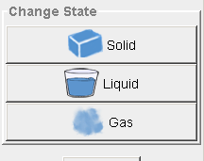
5. Experiment with the
Choose one of the materials from the Molecules box – neon, oxygen, argon or water
Click on the solid, liquid and gas picture buttons until you can see the differences.
6. Draw a picture to represent the atoms or molecules during each state.
Solid | Liquid | gas

7. Go to the second tab up at the top of your screen. 

Observations: 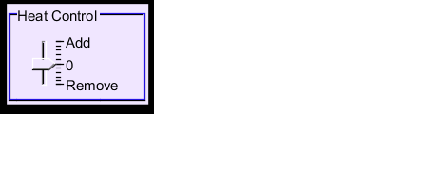
Move the arrow up and down.
Be sure to watch and discuss what is happening to the thermometer and the pressure gauge.

Draw arrows ( ) to show what you observed.
When we add energy: ,
Temperatue:  ( ) | Speed of molecules  ( ) | Pressure:  ( )
When we take away energy: ,
Temperature:  ( ) | Speed of molecules:  ( ) | Pressue:  ( )

What happened to the speed and arrangement of the molecues as heat was added?
____________________________________________________________________

Frame: When heat is added, we noticed that the particles ______________________. When heat was taken away, we noticed that the particles ________________________.
You have finished the lesson! Please have the teacher check the box!
More to Explore:
and There are some interesting features in this simulation.
Experiment with them to find out how they “move” and what they do. When you think you have a good idea of how to use each feature, go on to the next step.

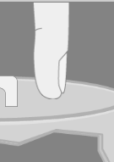
Draw arrows ( ) to show what happens.
Use the  to add matter: (you choose the number of pumps! ______)
Temperature:  ( ) | Pressure:  ( )
Use the 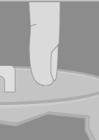 to reduce the space in the container ( decrease the volume).
Temperature:  ( ) | Pressure:  ( )
Write about two things you discovered:
#1
#2

