Mechanical Energy Explorations Pre-simulation: Name:__________________
Look at the dog (*) and the bar graph (*).
- When the dog starts to move again, what will happen to the kinetic energy (KE) bar on the graph?
  - KE will increase/go higher- because the dog continues to move faster going down the hill.

  - KE will decrease/go lower -because the dog is slowing down.
  - KE will stay the same -because kinetic energy always equals potential energy
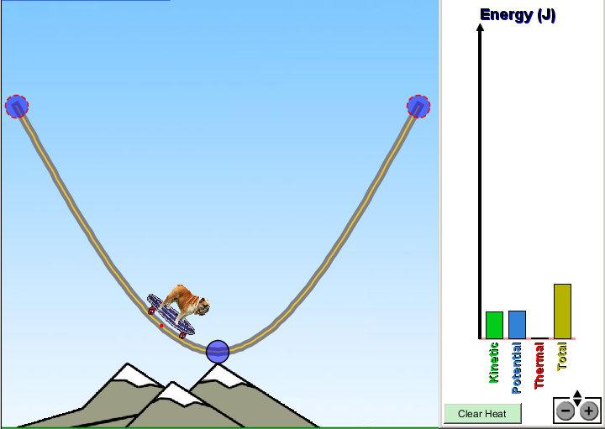
*
*

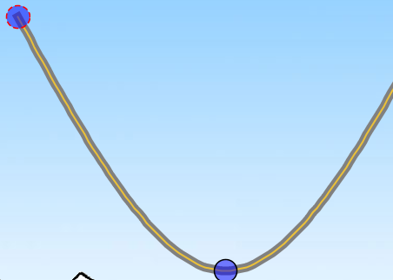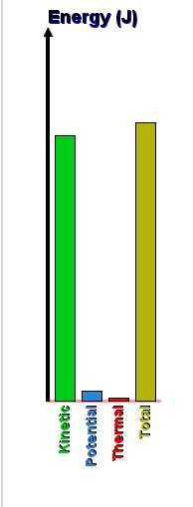
A.
C..
B
Look at the positions labeled on the track
and the bar graph information:
(circle your answer)
2. The bar graph matches _____ best.
Position A. Position B. Position C.
3. Friction is shown in this system.
yes no not enough information

3. For a science fair project, you and a friend decide to order a kit to build a roller coaster. It is smaller than a real roller coaster, but you and your friends will be able to ride on it! When your kit arrives at your house you begin work on the instructions.
- The first instruction is to watch a video and build the coaster on your computer as a model for the real roller coaster.
- Your first three steps of your computer design look like this:
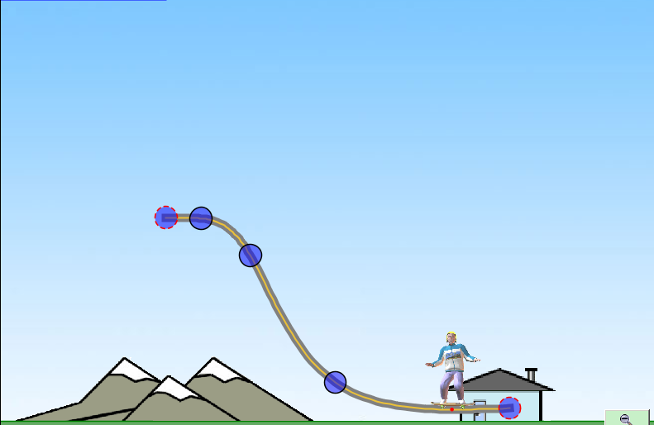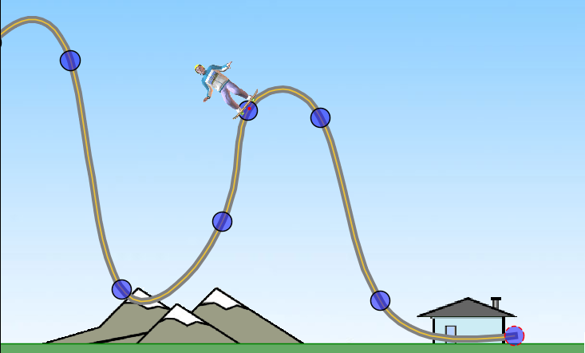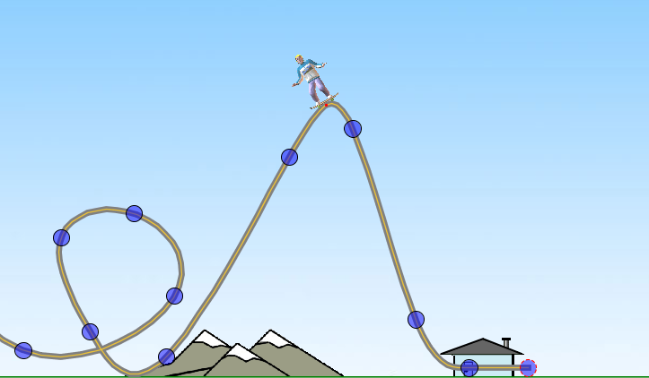
start
Step 1- up first hill Step 2- up 2nd hill by coasting Step 3- complete the loop
(no added energy) (no added energy)
- You show your computer model to the teacher.
- Your science teacher loves your project!! She would like you to answer the following questions to explain your thinking.
1. Looking at Step 1- How can you get the coaster-car from start to the top of the first hill?
________________________________________________________________________________
________________________________________________________________________________
2: Looking at Step 2- If you want to get the car over the second hill just by coasting, what must you do in your design?
________________________________________________________________________________
________________________________________________________________________________
3: Looking at Step 3-The loop in your designed is really cool! Why do you think the coaster will be able to move through the loop and continue down the track?
________________________________________________________________________________
________________________________________________________________________________

After the simulation, you and a partner will build a marble roller coaster. Sorry, it will only be big enough for a “marble passenger”, but it is still fun to build! Before we build in class, you can go back to the skate-park simulation and build your own track. Be sure to “save” it so you can share with the class.

