Blissfield Physics Name_______________
DC Series Circuit Online Lab
PhET http://phet.colorado.edu/en/simulation/circuit-construction-kit-dc

First draw a schematic diagram of a 10 Ω, 20 Ω, and a 30 Ω resistor in series with a 30 volt battery. Make sure to indicate the direction of the conventional current flow.

Calculate the effective resistance.

Draw the reduced equivalent circuit here. Be sure to indicate the conventional current flow.

Calculate the current in the circuit.

Calculate the voltage drops.

V1 = __________

V2 = __________

V3 = __________

Create the above circuit on the PhET website. Check the voltage drops with the voltmeter and check the current with the non-contact ammeter.

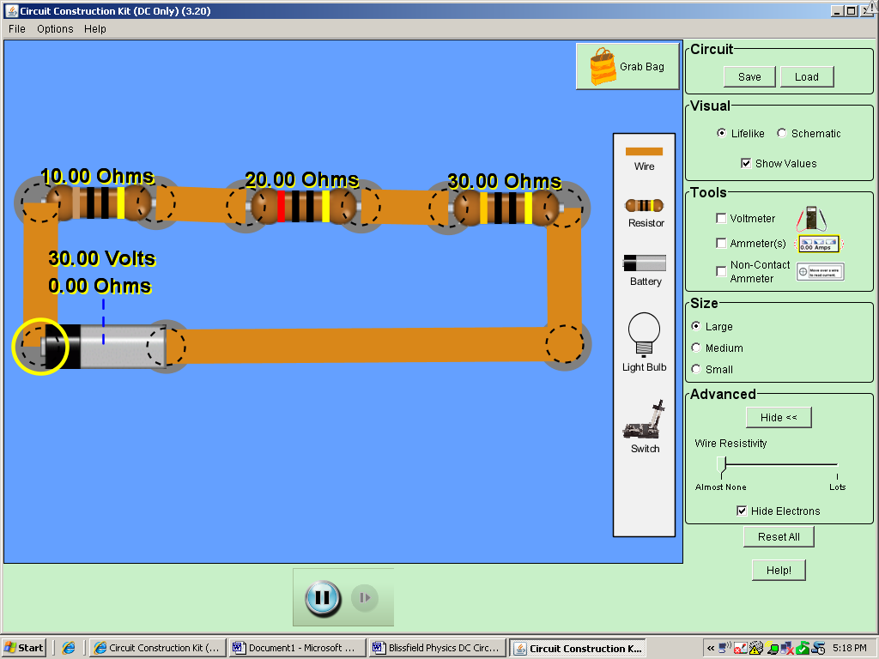

How did your predictions compare with the answers from PhET?

