Name_______________________________________ Period_______________________________
PhET: Reactants, Products & Leftovers
Essential Question: How do physical and chemical changes affect our lives and our choices?
Learning Goal: I understand that chemical changes make new chemicals (new molecules) while physical changes just rearrange the old chemicals.
Learning Objectives: I know reactants are at the start of a chemical reaction and products are after the chemical reaction has stopped.
I can identify evidence that mass is conserved in a physical or chemical change.
Review:
- Physical change – the chemicals before and after are the same but the molecules have been rearranged.
  - For example, sugar and water are mixed. Sugar water is still similar to both sugar (sweet) and water (a liquid) but the molecules have been rearranged.
  - For example, wax is melted. Liquid candle wax is still similar to solid candle wax (same color and waxy feeling) but the molecules have spread out and move faster in the liquid.
- Chemical change – new chemicals are made from the chemicals before. The molecules from before have been broken down and reformed into new, different molecules after.
  - For example, water is split into hydrogen and oxygen. Water molecules as a gas put a flame out. But after splitting water, the hydrogen gas molecules explode in a flame and the oxygen molecules burn in the flame. The water molecules and broken down and reformed into new, different molecules after.
  - For example, a candle is burned. The wick turns from a white string to black ash. The molecules in the candle break down into CO₂ and smoke. Candle wax and the wick will burn but the black ash, CO₂ and smoke will not.
Procedure:
1. Run the Reactants, Products and Leftovers PhET. You’ll start in the sandwich shop. Explore the Sandwich shop.
2. Where are the reactants? Where are the products?

3. ReAcTanTS and PrOducTS – Unscramble the bolded, capitalized letters. What words can you find? Which word means start? Which word means stop?

4. Try putting in different amounts of bread, cheese and meat while the formula says no “Reaction” . What happens?

5. Is making a sandwich a chemical or physical change? Use evidence from the definitions above or from the PhET to support your answer.

6. Draw one sandwich you made below. Include the formula at the top. Label the reactants, products and any leftovers.

7. Look at your picture for 6. Explain how this picture is evidence that mass is conserved when you make a sandwich.

Real Reaction
Click on the Real Reaction tab at the top of the PhET. Start with Making Water. Explore and then answer the questions below.
8. Where are the reactants? Where are the products?

9. What’s the formula for making water?

10. Is making water a chemical or physical change? Use evidence from the definitions above or from the PhET to support your answer.

11. Write down the amounts of the reactants and products you need to make water with no leftovers. Answers may vary!
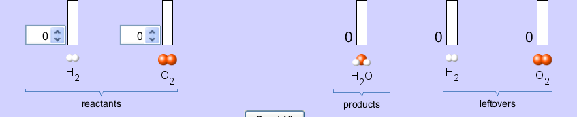
12. Write down the amounts of reactants and products you need to make water with H₂ OR O₂ leftover. Answers may vary!
Try the other two chemical reactions (making ammonia and combusting methane).
13. What is the relationship between the formula and leftovers?
Explain using:
- reactant amounts that gives you leftovers and
-reactant amounts that do not give you leftovers.

14. Are the atoms conserved during a chemical change even though new molecules are made? Use evidence from the PhET to support your answer.

15. Remember, atoms give matter its mass. Draw a picture showing how mass is conserved during a chemical change.

16. What if H₂ and O₂ never combined to make water? How would your life be different?

17. The reaction for the combustion of methane is very similar to the cellular respiration in your cells as well as the chemical reaction that occurs when we burn wood for a fire. Cellular respiration and burning wood are both chemical reactions. How would your life be different if there were no chemical reactions?

Answers
2. Where are the reactants? On the left or Before “reaction” Where are the products? On the right or After “reaction”.
3. ReAcTanTS and PrOducTS – Unscramble the bolded, capitalized letters. What words can you find? Which word means start? Which word means stop?
START and STOP. Reactants means start. Products means stop.
4. Try putting in different amounts of bread, cheese and meat while the formula says no “Reaction” . What happens?
The bread and cheese do not combine. They are all just leftover.
5. Is making a sandwich a chemical or physical change? Use evidence from the definitions above or from the PhET to support your answer.
Making a sandwich is a physical change.
Evidence from above:  “The chemicals before and after are the same” when you make a sandwich. You have bread and cheese before and you have bread and cheese after in your bread & cheese sandwich. No new chemicals are made. | Evidence from the PhET:  The PhET shows cheese and bread as the reactants and the product still shows cheese and bread. However, the product shows the cheese and bread rearranged into a sandwich.
6. Draw one sandwich you made below. Include the formula at the top. Label the reactants, products and any leftovers.
Answers will vary.
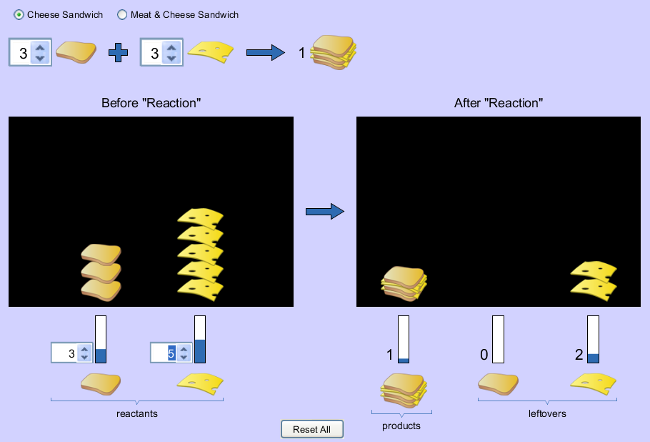
7. Look at your picture for 6. Explain how this picture is evidence that mass is conserved when you make a sandwich.
I started out with 3 pieces of bread and 5 pieces of cheese. When I made my sandwich, I used 3 pieces of bread and 3 pieces of cheese. This gave me two pieces of cheese left over. All the matter I started with was there when I was finished physically changing it into a sandwich. This shows that the mass is conserved because the matter was conserved. All the cheese and bread I started with made all the cheese and cheese sandwiches I ended with.
Real Reaction
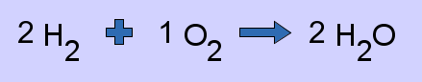
8. Where are the reactants? On the left or Before “reaction” Where are the products? On the right or After “reaction”.

9. What’s the formula for making water?
10. Is making water a chemical or physical change? Use evidence from the definitions above or from the PhET to support your answer.
Making water is a chemical change.
Evidence from above:  “The molecules from before have been broken down and reformed into new, different molecules after.” The H₂ and O₂ molecules are broken apart and recombined into H₂O molecules where the Hs are each hooked to an O atom instead of to each other. | Evidence from the PhET:  The PhET shows white H₂ molecules and red O₂ molecules before the reaction. After the reaction, a new red and white molecule H₂O is formed. H₂O is a new, different molecule so making water must be a chemical change.

11. Write down the amounts of the reactants and products you need to make water with no leftovers. Answers may vary!
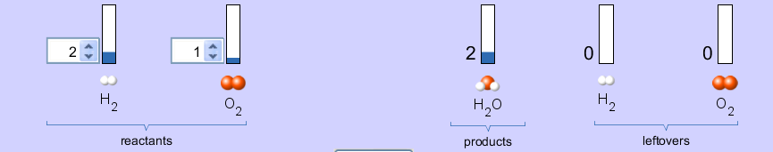
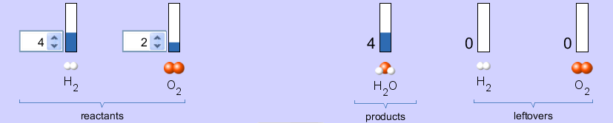

12. Write down the amounts of reactants and products you need to make water with H₂ OR O₂ leftover. Answers may vary!
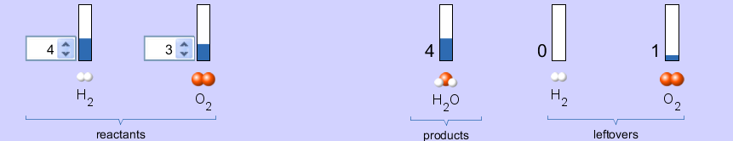Try the other two chemical reactions (making ammonia and combusting methane).
13. What is the relationship between the formula and leftovers?
Explain using:
- reactant amounts that gives you leftovers and
-reactant amounts that do not give you leftovers.
If one follows the formula exactly or if one doubles or triples the formula, there will be no leftovers. For example, for the formula 2H₂ + 1O₂ → 2H₂O, if I use 4H₂ + 2O₂, I’ll have 4 H₂O and no leftovers. However, if I do not follow the formula or a multiple of the formula, I’ll have leftovers. For example, if I use 5H₂ + 3O₂ → I’ll have 4H₂O and 1 leftover H₂ and 1 leftover O₂. Formulas tell me how to combine reactants so that I will have no leftovers.

14. Are the atoms conserved during a chemical change even though new molecules are made? Use evidence from the PhET to support your answer.
Even though chemical changes make new molecules, the atoms are conserved. For example, when I combined 4H2 molecules and 2O2 molecules into 4H2O molecules all the atoms I started with were the atoms I ended with. The H2 molecules and O2 molecules were changed from flammable molecules into non-flammable water which shows this was a chemical change. Even still, the 8H atoms I started with are still there as the 2 white atoms attached to each of the 4 red atoms. All 8 white atoms I started with ended up in my products and leftovers. All 4 red atoms I started with in my reactants ended up in my products or leftovers. No atoms were created or destroyed. They were just rearranged into new molecules.

15. Remember, atoms give matter its mass. Draw a picture showing how mass is conserved during a chemical change.
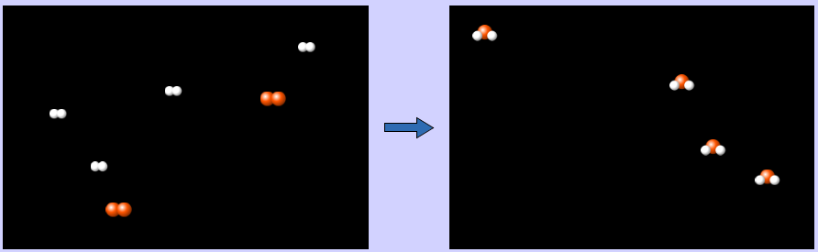

16. What if H₂ and O₂ never combined to make water? How would your life be different?
Answers will vary. If H2 and O2 never combined to make water, I would die in two days from thirst. There would be no rain showers, no snow days and I couldn’t go swimming at the pool.

17. The reaction for the combustion of methane is very similar to the cellular respiration in your cells as well as the chemical reaction that occurs when we burn wood for a fire. Cellular respiration and burning wood are both chemical reactions. How would your life be different if there were no chemical reactions?
Answers will vary. If there was no cellular respiration, I would die because my cells wouldn’t be able to give my body energy. Plants would die too because plants need cellular respiration to live. So there would never be any wood to burn. If there were no wood to burn, human society would likely have never started; I’d have to always eat raw meat and people probably wouldn’t live in continental or polar climates.

